Student Registration Database Management System

Nyasa Gupta, Piyush Kumar, Prerna Sharma, Shashank Tripathi, Dr. S. Thenmalar

Department of Networking and Communications,

SRM Institute of Science and Technology, Chennai – 603 203

# Abstract: - In a school, there are many departments which provide various records regarding student. Most of these track records need to maintain information about the students. Thus, by proposing a computerized student record management, the users will be able to access data at any time and any place. In this project, an automated student registration database management system is made which enables the users (faculties and other staff) in a school to access the important information with ease through a user-friendly web portal. This proposed system aims at eliminating the practice of time consuming and vulnerable tradition of manual maintenance of student information in paper at the very basic level. The student web portal enables huge storage of data and easy retrieval, centralizing the administration to work as a single entity. This project will also suggest how to successfully implement the computerized procedure and to overcome the obstacle that would hinder the successful implementation of the system. It aims to minimize both the paper work and staff in each department and function efficiently.

1. **INTRODUCTION**

Traditional system which was mainly paper-based, required large amount of space to store information. It limits the exchange of information, updating and causes loss of documentation. A collaborative work in this system becomes rigid and degrades performance. It was a manual operated system where a new student is registered manually and admission number, student name along with other details are recorded. The school uses manual system in the process of administration and all its data is stored on paper and maintained in files.

After the student is assigned his/her class, another record is written down. Also, the person in charge of admission has to count the number of students manually. The school administration collects information from the student: student personal details like their names, admission dates, phone number, address and parents’ details are kept. During the admission a student is issued with admission number. This work become more tedious and also wastage of time with high cost of operation. The proposed solution eliminates this issue in an organized and efficient manner.

This project on student registration management system is one complete information management solution for students and staff of any educational institution. In today's world, it is a need to organize huge amount of data than ever before. In the absence of a great infrastructure for faculties, students and departments, management to exchange data, crucial information about students and organizations can be misplaced, which can cause loads of problems that can affect the reputation of the organization.

For an academic institution, the data handling should be an easy task for which online approach is a must. Following which the proposed system uses internet as the solution for global access of data, record keeping and managing details of students which makes the student management system centralized. The system is designed to be a web based service that is hosted on a web server. It is designed around a relational database management system (MySQL). The system user interface and business logic was coded using HTML, PHP, CSS, and JavaScript. Being web based, the system was deployed on a web server with MySQL and PHP capabilities. It also proves to be user-friendly and cost efficient process. At one time, the school depended intensely on paper records for this activity . The management employees can now easily use this system to create records, keep attendance records, fee payment status which were considered to be very time-consuming activity.

The person who will be in charge of the system will be able to log into the system and able to register new students and also be able to track student information. Management staff can update the details of students taking admissions. The students are categorized by their departments and sections. The details of admissions of newly admitted batch are added to the system and existing details are modified according to the year of admission. This system can be extended further to store the accounting details of the students that can be updated and modified by the accounting department. Updates such as fees paid, or unpaid and defaulters list are generated here.

## OBJECTIVES OF THE PROPOSED SYSTEM:

* Capture, display and print student details
* Allocate admission number of every student
* Amend, delete and edit
* Allocate student to the registered class
* Print student identity card
* Capture department details
* Capture class details
* Allocate student to classes
* Display active and non-active student
* Capture registration form
* Generate class, registration and student report forms

## ADVANTAGES OF THE PROPOSED SYSTEM:

* Increase the performance speed
* Lesser/lower clerical and operating cost
* Improve accuracy of information.
* Reduce cost of files and writing materials
* It will save time for administrator while working on a record
* Spend less office space for example reduction on use of many files and paper work.
* The system will reduce redundancy of data.
* Maintain information on computer files to be updated as it changes occurs.
* Retrieve the required information easily and quickly.

# RELATED WORK

This section presents a review of related literature to the study of management information system and students records; the review has been done in accordance with the research objectives which has impact of computerized data collection on maintenance of student record, computerized information protection on student record and computerized record management in maintenance of students’ records. Literature was reviewed from various sources, like from research papers, publications books, existing bibliographic information, and recommendations by the project panel. These research papers has provided us sufficient amount of data for the survey.

**AUTOMATION TECHINIQUE TO INCREASE EFFICIENCY:**

Automation can be defined as the process of reducing or minimalizing the manual hard work with help of computers, computer operated software and devices. There are certain works that are beyond human capacities which can be carried out through automation techniques. Library Automation System of the University of Toronto in 1963-1972 was one of the first achievements to manage the data with the help of automated system. The real idea of implementing Automation is to enhance efficiency, reduce delays, increase production flexibility, reduce prices, human error elimination, and alleviate labor shortage, high degree of accuracy. Automation in Educational Assessment created in Nigeria shows how an online automation system can be implemented to eradicate human errors and bring fairness during the exams. Defining the Paperless Workplace with the Paper Metaphor, has explained the difficulties faced by the organization while switching from conventionally used paper based system to an online automated system as they were not able to draw the gap between both the systems but automated Project Grading & Instant Feedback System provides an example of an automated system which enhances the efficiency of manual project grading system with feedbacks can being easily managed.

**THEORETICAL UNDER-PINNING OF THE STUDY:**

According to the university of Florida(2012) explained that student is an individual who is registered for a university credit course or program. A student record, also known as an educational record , obtains information directly related to a student, which means that the record is personally identifiable. Personal identifiers that relate a record to a student include student name , student id, student address , parent/family member names, and list of personal characteristics. Students’ records are maintained in multiple media including handwriting, print, computer’s main memory, magnetic tapes, cassette ,disk pr CD etc. Students’ records may be presented by student, submitted on behalf of the student ,or created by the university. These records are used to assist offices in their support of basic institutional objectives and document student progress and achievement in the educational process of the university.

**COMPUTERIZED DATA COLLECTION ON MAINTAINENCE OF STUDENT RECORDS:**

According to Sharapova(2014) noted that systematic literature review was employed as follows:

1. A variety of combinations of search strings were applied to selected scientific databases and search engines. The search string matrix was developing continually through output the review process.
2. Papers pre-selected on the basis of their title and abstracts were downloaded to the citation manager, together with their full text.
3. All duplicates ,multiple entries and irrelevant papers were removed; remaining papers were scanned for information of interest.
4. When a relevant document was cited that had not been previously identified by database queries ,it was downloaded.

# COMPUTERIZED INFORMATION PROTECTION ON STUDENTS RECORD:

According to Kyobe, South African university (2009) explained that computerized Information security issues (e.g., access to information, cyber-crime, privacy, and virus Attacks, and commercial data mining) are major concern in academia today Myler and Broadbent (2006). According to Wamukoya and Mutual (2005) noted that poor security and

confidentiality controls have been identified as major factors contributing to the failure of capturing and preservation of electronic records in eastern and southern African institutions of education. Chinyemba and Ngulube (2005) found that 89% of the academic surveyed at the university of KwaZulu-Natal did not adequately protect and secure their electronics records. Jones and Soltren (2005) found that 58% of the students surveyed were not concerned at all about risks to privacy on social network sytems. However, little protection of the information of the student is not secure because other students access the information about other students or colleagues without permission hence the need for proper protection for the student records well.

# COMPUTERIZED RECORD/DATA MANAGEMENT ON MAINTENANCE OF STUDENT RECORD:

According to student records manual prepared by the University of South Florida the creation and maintenance of records relating to the students of an institution are essential to:

* + Managing the relationship between the institution and the student;
  + Providing support and other services facilities to the student;
  + Controlling the student’s academic progress and measuring their achievements ,both at institution and subsequently;
* Providing support to the student after they leave the institution .In addition , student record contain data which the institution can aggregate and analyze to inform future strategy, planning and service provision. Educational universities and agencies are required to confirm to fair information practices. This means that person who are subjects of data systems must:
  + - Be informed of the existence of such system.
    - Have identified for them what data about them are on record,
    - Be given assurances that such data are used only for intended purposes.
    - Be certain that those responsible for data systems take reasonable precautions to prevent misuse of data.

# SYSTEM OVERVIEW

Student registration database management system is the process of managing student’s record in an institutional organization. It is done through the online method which traditionally, was prepared using papers and manual ledgers. It preserves student’s and administrator’s resources. This system provides a simple interface for the maintenance of student information. The design of the student registration management system contains the home page which is the first page of the system. The home page provides the login page using which user (school management or staff) can login in the system using their unique login credentials. It is also backed by a sensitive key that serves as two-factor authentication, providing additional security to environment.

The system involves registering the students’ details and maintaining records. Being an online system, the availability of information is worldwide which means accessibility and exchange of information is global. This data is stored safely in the repository that makes it simple to acquire and data modification can be done whenever required. It is the software created for everyday student record management in academic institutes. It helps to fetch the data of student from a specific class just by few clicks. This system will also help in generating a status report of a student such as total attendance, the event requested, fee payment details, admission info, and so on. Click on the mouse and the system will produce the students' report which reduces the requirement for manual labor which is vulnerable to errors and time expenditure. This application is constructed for automated processing of student record management. It even enhances the speed of solving tasks. The Student information will be stored according to the batch, department, and section.

# SYSTEM DESIGN

The system contains 2 main modules followed by sub-modules. The modules are Teaching and other staff (user) and the School Administration (Administrator). The login page is the same for each module. A login ID, password and sensitive key may be seen on the login page. Users should log in to the system by putting data into that field.

* *Teaching and other Staff (User) Module*

Once a student registers in school, the teaching and other concerned staff need to add the new entries to existing record and administration provides them with user credentials to log into the system. Due to the role-based access model the staff will get only those privileges for which they are accountable. The students are categorized by their departments and sections. The details of admissions of new student are added to the system and existing details are modified according to the year of admission.

* *School Administration (Administrator) Module*

The school administration has the responsibility of handling the entire system. They have an eye on each activity of the system. They can check the new user in the system and updates in the basic details of the student like change in name, mobile number, email-ID, address etc. They are responsible for removing the unwanted user. This can be further extended and the administration can also provide accounting features to accounting staff such as fee details of the students to be updated. Updates such as fees paid, or unpaid and defaulters list could be generated in that scenario.

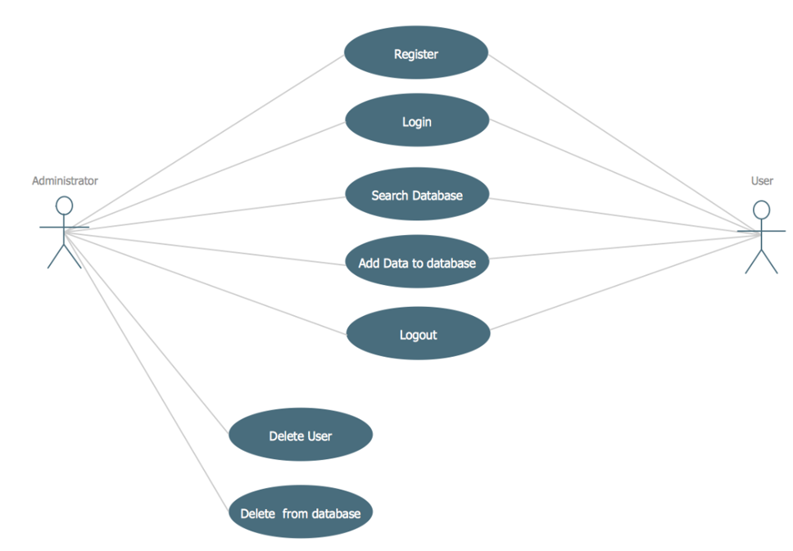

Fig 1: Use-case Diagram

1. **TECHNOLOGY USED**

* NetBeans
* Java
* SQL
* JS + CSS
* Django Modules
* Structured Tables
* PHP

1. **IMPLEMENTATION**

Figure 2 and 3 depict the login interface for the Student Registration Database Management System. The user enters the username and password to login into the system. The users with correct login credentials only can successfully login into the system. It is also provided with sensitive key that enables two-factor authentication, providing more security.

.

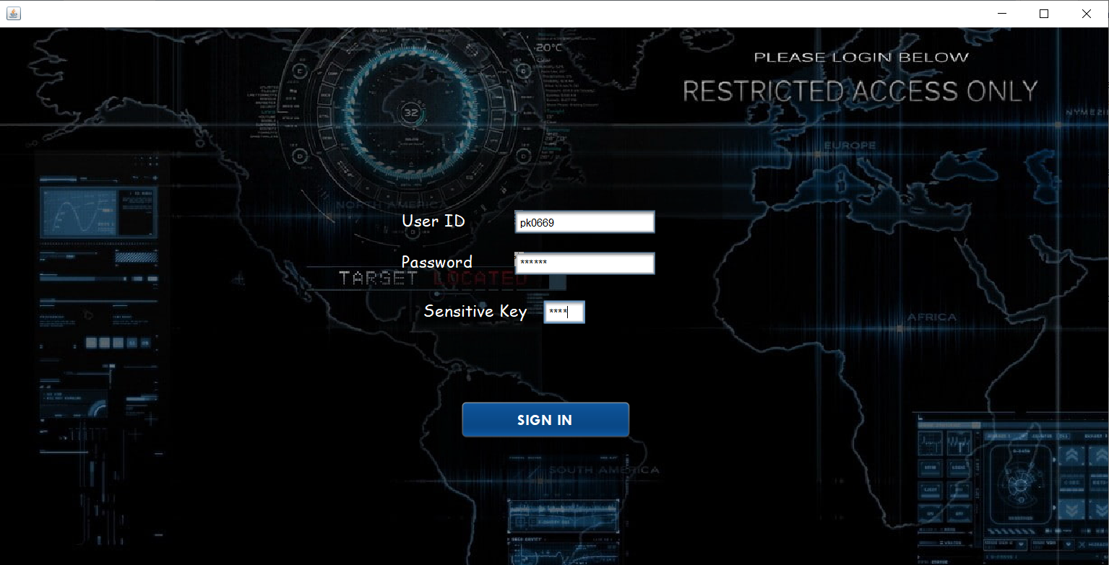

Fig 2: Login page

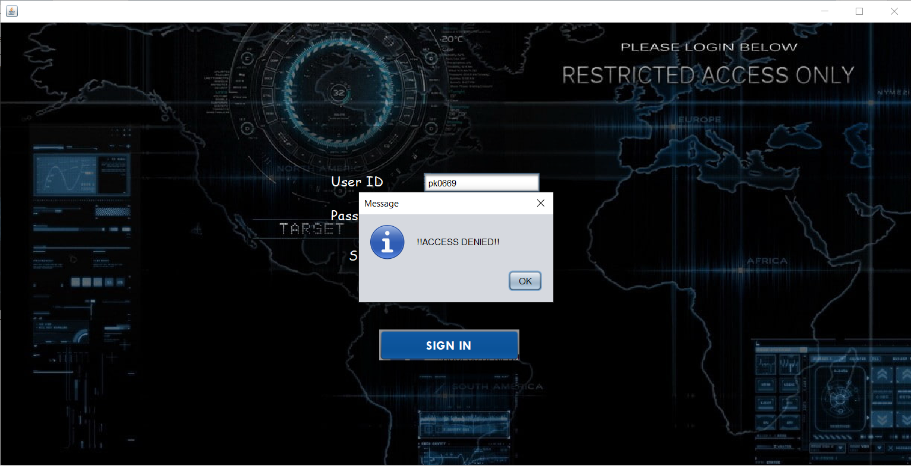

Fig 3: Login Page (Access Denied)

Figure 4 displays the Registration page. New students are registered into the system using this form. In this form, the school management or staff enter student’s details. After providing all details, the student gets registered into the system.

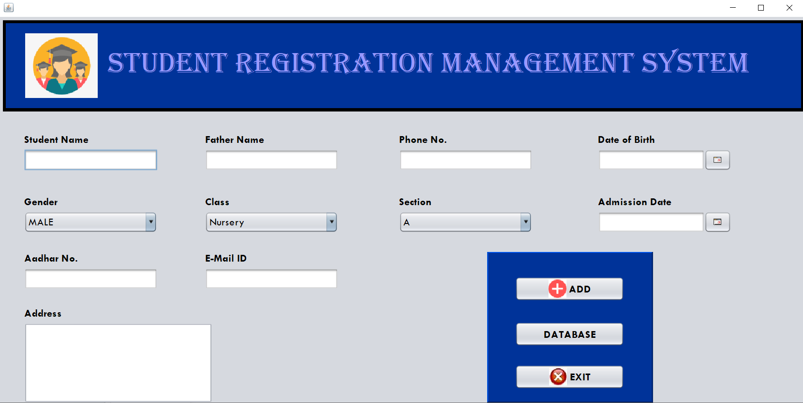

Fig 4: Registration Page

Figure 5 and 6 display the Database Dashboard. The student data is being stored in an efficient manner in the following table. The SEARCH option facilitates the student search by entering only the initial details that can lead to all records of student.

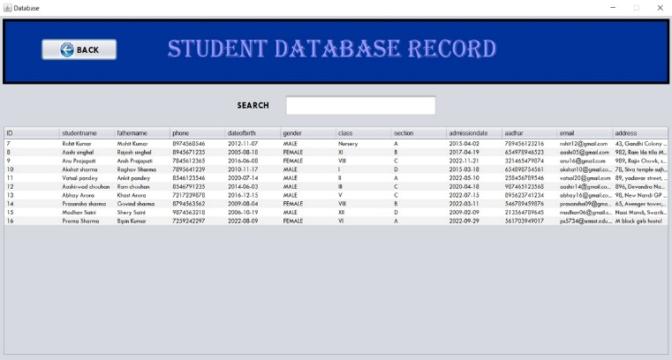

Fig 5: - Database Dashboard (Student Record)

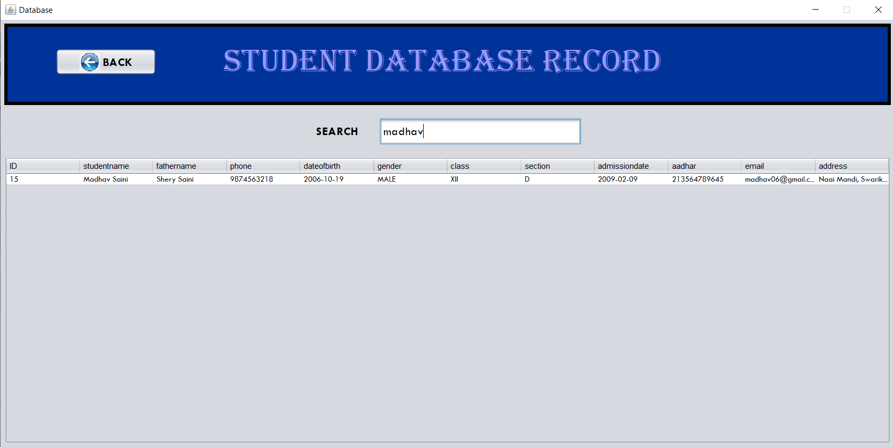

Fig 6: - Database Dashboard (Search Detail)

In Figure 7, the Dynamic Database Storage is displayed. The database is stored using PHP that is dynamic in nature i.e., size of the database and the storage period is extensible and can be changed as per the system requirement.

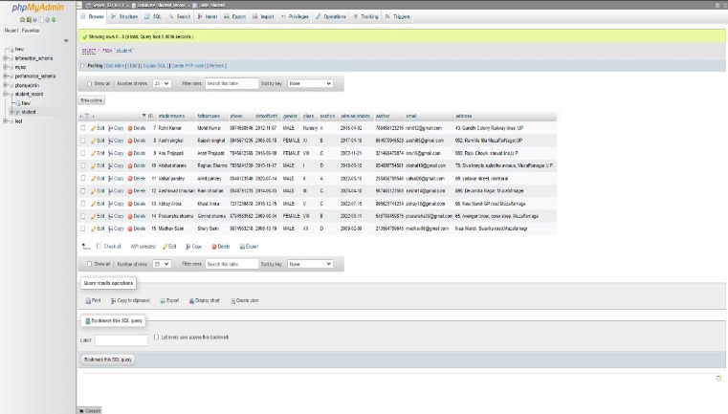

Fig 7: - Dynamic Database Storage

1. **RESULT AND DISCUSSION**

This project is developed using technologies like NetBeans, Java, SQL, JS + CSS, Django Modules, Structured Tables and PHP. There are some aspects for the future scope of this project. The GUI design can be made more user-friendly with added functionalities so that it can gain more traffic to the site which prompts greater use of the system among schools. The user will be able to download the entries for offline requirements. More facilities to both students and teachers will be added. The efficiency can be improved: Database connection can be pooled to minimize the system overhead. The whole system will be made available as an Android application to encourage widespread availability on any device and be more convenient to users.

# CONCLUSION

Student Management System can be used by educational institutions to maintain their student records easily. Achieving this objective is difficult using the manual system as the information is scattered, can be redundant, and collecting relevant information may be very time-consuming. All these problems are solved by this project. Finally, with due diligence, the student management web-based Application system is carried out. It is system that assists the user to work with the day to day activities involved in the academic institution. It helps in maintaining the information of students of a school. It lessens the amount of manual hard work and provides greater efficiency diminishing the amount of time taken for detailing different modules. The interface provides user-friendly experience to everyone. It can be easily accessed by the manager and kept safe for a long period of time without any changes. Only verified users can access the information concerning students. The project successfully aims at reducing the unnecessary delay, uncertainty, and imperfect information of the existing Manual System. It is an easy-to-use graphical user interface and provided the user few key components, security and reliability for data. In nutshell, we can say that the performance of this new system is accurate, precise and it successfully performs the assigned tasks.

# REFERENCES

1. Ritvars Bregzis, Calvin Gotlieb, Carole Moore. The Beginning of Automation in the University of Toronto Library, 1963-1972, in IEEE Annals of the History of Computing, 2002.
2. Prof. Godswill Obioma, Prof. Ismail Junaidu, Dr. Grace Ajagun. The Automation of Educational Assessment in Nigeria: Challenges and Implications for Pre-service Teacher Education, 39th Annual Conference of the International Association for Educational Assessment.
3. Prita Patil, Kavita Shirsat. An Integrated Automated Paperless Academic Module for Education Institutes, International Journal of Engineering Science Invention Research & Development. 2015; I:IX.
4. Sarthak Langde, Avinash Maurya, Tanvi Nakhawa, Anurag Sinha, Smita Patil, Kriti Karanam and Harshali Mugutrao. Automated Attendance System, International Journal of Applied Research. 2018; 248-249.

1. Prabhu T Kannan, Srividya K Bansal,"Unimate: A Student Information System",2013 International Conference on Advances in Computing, Communications and Informatics (ICACCI)-p-1251-1256
2. Suraj Kishor Desai, Shahrukh Attar, Sonali Haridas Mane, Kalyan Bandu Dethe and Archana Lomte. Online Scientists Information System using AES. International Journal of Computer Applications 176(11):29-31, April 2022
3. System and method for communicating student information among student, parents guardians and educators.(US 20060127870 A1)
4. Web service API for student information and course management systems(US20080085502A1)
5. Student pecific Information System.(US20120237917A1)